CS 255 Business Requirements Document Template

Complete this template by replacing the bracketed text with the relevant information.

This template lays out all the different sections that you need to complete for Project One. Each section has guiding questions to prompt your thinking. These questions are meant to guide your initial responses to each area. You are encouraged to go beyond these questions using what you have learned in your readings. You will need to continually reference the interview transcript as you work to make sure that you are addressing your client’s needs. There is no required length for the final document. Instead, the goal is to complete each section based on your client’s needs.

Tip: You should respond in a bulleted list for each section. This will make your thoughts easier to reference when you move into the design phase for Project Two. One starter bullet has been provided for you in each section, but you will need to add more.

System Components and Design

Purpose
What is the purpose of this project? Who is the client and what do they want their system to be able to do?
- The purpose of this project is to design and develop a system for DriverPass that supports online driver training and scheduling services.
- DriverPass is a company focused on helping students pass their driving tests by providing online practice exams and on-the-road training.
- The system will allow users to access training materials, schedule driving lessons, manage accounts, and track progress.
- The system will also allow administrators to manage users, monitor system activity, and maintain system functionality.

System Background
What does DriverPass want the system to do? What is the problem they want to fix? What are the different components needed for this system?
- DriverPass identified a problem where a large percentage of students fail their DMV driving tests due to inadequate preparation.
- The company aims to solve this problem by offering structured training that includes online classes, practice exams, and in-person driving lessons.
- The system will be a web-based platform that allows users to access services from any device with internet access.
- The system must remain up to date with DMV rules and test content through external updates and notifications.
- The system consists of the following components:
  - Administration (Owner/Management): Oversees business operations and system performance.
  - IT Officer: Maintains the system, manages user access, resets passwords, and ensures security.
  - Secretary: Schedules appointments for customers via phone or in-person requests.
  - Customer (Student): Registers accounts, schedules lessons, takes online tests, and tracks progress.
  - Driver: Conducts lessons and logs session details and feedback.
  - Vehicles: Assigned to drivers and scheduled for lessons.
  - Reservation System: Manages lesson scheduling, cancellations, and modifications.
  - Online Learning Module: Provides training content and practice tests.
  - Database System: Stores user data, reservations, progress, and activity logs.

Objectives and Goals
What should this system be able to do when it is completed? What measurable tasks need to be included in the system design to achieve this?
- Objectives (high-level):
  - Provide an online platform for driver education and training.
  - Enable scheduling and management of driving lessons.
  - Track user progress and performance.
  - Maintain accurate and secure system records.
  - Support multiple user roles with different permissions.
- Goals (measurable outcomes):
  - Allow customers to create accounts and manage personal information.
  - Allow customers and staff to schedule, modify, and cancel driving lessons.
  - Provide online practice tests and track results.
  - Maintain a complete activity log of all system changes.
  - Ensure system updates reflect current DMV rules and requirements.
  - Enable administrators to manage user access and system settings.

Requirements

Nonfunctional Requirements
In this section, you will detail the different nonfunctional requirements for the DriverPass system. You will need to think about the different things that the system needs to function properly.

Performance Requirements
What environments (web-based, application, etc.) does this system need to run in? How fast should the system run? How often should the system be updated?

Performance Requirements
- The system shall operate as a web-based application accessible from desktop and mobile devices.
- The system shall load pages and user data within 3–5 seconds under normal conditions.
- The system shall support multiple concurrent users without performance degradation.
- The system shall update DMV-related content automatically when new information is available.
- The system shall allow report downloads (e.g., Excel) without significant delay.

Platform Constraints
What platforms (Windows, Unix, etc.) should the system run on? Does the back end require any tools, such as a database, to support this application?
- The system shall run on a web-based platform accessible through modern browsers (Chrome, Edge, Safari).
- The system shall be hosted on a cloud-based infrastructure for scalability and reliability.
- The system shall use a centralized database to store user data, reservations, and progress.
- The system shall require an internet connection for all data updates and transactions.
- The system shall integrate with external DMV systems for updates.

Accuracy and Precision
How will you distinguish between different users? Is the input case-sensitive? When should the system inform the admin of a problem?
- The system shall distinguish between user roles (Admin, IT Officer, Secretary, Customer, Driver).
- The system shall validate all user input (e.g., required fields, correct formats).
- The system shall track and log all changes made to reservations, including who made the change and when.
- The system shall ensure accurate matching between customers, drivers, vehicles, and scheduled times.
- The system shall notify administrators of inconsistencies or system errors.

Adaptability
Can you make changes to the user (add/remove/modify) without changing code? How will the system adapt to platform updates? What type of access does the IT admin need?
- The system shall allow administrators to enable or disable training packages without modifying core code.
- The system shall support future updates for adding or modifying system features.
- The system shall adapt to updates received from external DMV systems.
- The system shall allow IT staff to manage user accounts and permissions.
- The system shall support system updates without disrupting core functionality.

Security
What is required for the user to log in? How can you secure the connection or the data exchange between the client and the server? What should happen to the account if there is a “brute force” hacking attempt? What happens if the user forgets their password?
- The system shall require users to log in using a unique username and password.
- The system shall allow users to reset passwords securely if forgotten.
- The system shall restrict access based on user roles and permissions.
- The system shall track login attempts and prevent unauthorized access (e.g., lock account after multiple failed attempts).
- The system shall encrypt sensitive user data (e.g., personal and payment information).
- The system shall maintain secure communication between client and server (e.g., HTTPS).

Functional Requirements
Using the information from the scenario, think about the different functions the system needs to provide. Each of your bullets should start with “The system shall . . .” For example, one functional requirement might be, “The system shall validate user credentials when logging in.”
- The system shall allow users to register and create an account.
- The system shall allow users to log in and log out securely.
- The system shall allow customers to schedule driving lessons.
- The system shall allow customers to modify or cancel reservations.
- The system shall allow the secretary to schedule lessons for customers.
- The system shall assign drivers and vehicles to scheduled lessons.
- The system shall allow customers to select training packages.
- The system shall provide online training materials and practice exams.
- The system shall track customer progress and test results.
- The system shall allow drivers to record lesson details and feedback.
- The system shall generate activity reports for administrative review.
- The system shall allow administrators to manage user accounts and permissions.
- The system shall allow administrators to disable or modify training packages.
- The system shall allow users to reset their password if forgotten.

User Interface
What are the needs of the interface? Who are the different users for this interface? What will each user need to be able to do through the interface? How will the user interact with the interface (mobile, browser, etc.)?
- The system shall provide a web-based interface accessible on desktop and mobile devices.
- The system shall include input forms for user registration and scheduling.
- The system shall display training progress, test results, and lesson history.
- The system shall allow users to interact through dashboards tailored to their role.
- The system shall provide clear navigation for scheduling, training, and account management.
- The system shall support report viewing and downloading (e.g., Excel format).
- The interface shall be user-friendly and easy to navigate for all user types.

Assumptions
What things were not specifically addressed in your design above? What assumptions are you making in your design about the users or the technology they have?
- Users will have access to a device with internet connectivity.
- Users will provide accurate and complete personal information during registration.
- The DMV system will provide updates that can be integrated into the platform.
- The system will be accessed through modern web browsers.
- Drivers and vehicles will be available according to the schedule.

Limitations
Any system you build will naturally have limitations. What limitations do you see in your system design? What limitations do you have as far as resources, time, budget, or technology?
- The system will not function without an internet connection.
- The system will not allow offline updates to prevent data inconsistencies.
- The system will depend on external DMV systems for updates and content accuracy.
- The system will not support full customization of training packages without developer intervention.
- The system may be limited by available vehicles and drivers for scheduling.
- The system will not operate if the cloud hosting service is unavailable.

Gantt Chart
Please include a screenshot of the GANTT chart that you created with Lucidchart. Be sure to check that it meets the plan described by the characters in the interview.
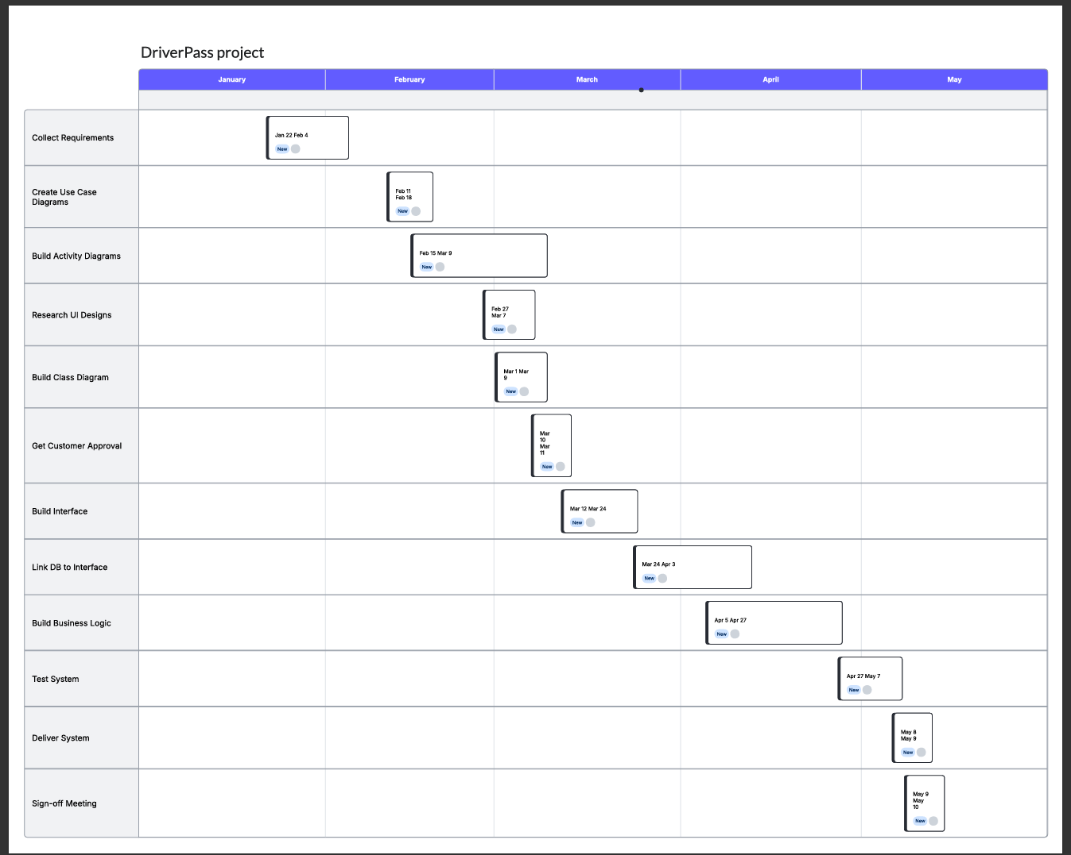
Figure 1: DriverPass Project Gantt Chart

